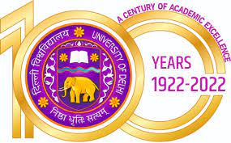
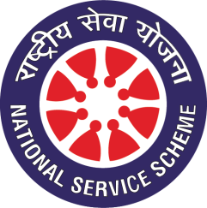
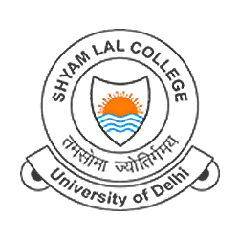

National Service Scheme
Report on
“Group Discussion on YUVA Pakhwada 2023”
17th January, 2023
Shyam Lal College (SLC), a co-educational constituent college of the University of Delhi, was established in 1964 by the great visionary and entrepreneur Padmashree (late) Shri Shyam Lal Gupta. SLC has earned its legitimate reputation as the most efficient and prominent educational institution in the entire East Delhi region.
SLC has become the centre of academic excellence since its inception and aims to make quality education accessible to the students, especially girls, from economically and educationally disadvantaged community of East Delhi. The endeavour of the College has always been to make higher education more committed, job oriented, meaningful and pragmatic, and at the same time more adaptable to the ever-changing demands of our society and globe.
Celebrating the National Youth Festival 5.O; CHD (CENTRE FOR HOLISTIC DEVELOPMENT) In collaboration with NSS (NATIONAL SERVICE SCHEME) organized various activities like Group Discussion on the topic “The relevance of Swami Vivekananda’s thoughts in the era of westernization and globalization” in college premises to increase awareness among the students of different courses about the relevance of Swami Vivekananda thoughts in today’s context. Students across different courses actively took part in it and discussed the various thoughts and philosophies of Swami Vivekananda Ji which could cater the needs of today’s youth collectively. They also discussed about the negative effects of westernization and globalization and how can today’s generation try to promote the rich and vast culture of ours along with modern traits.
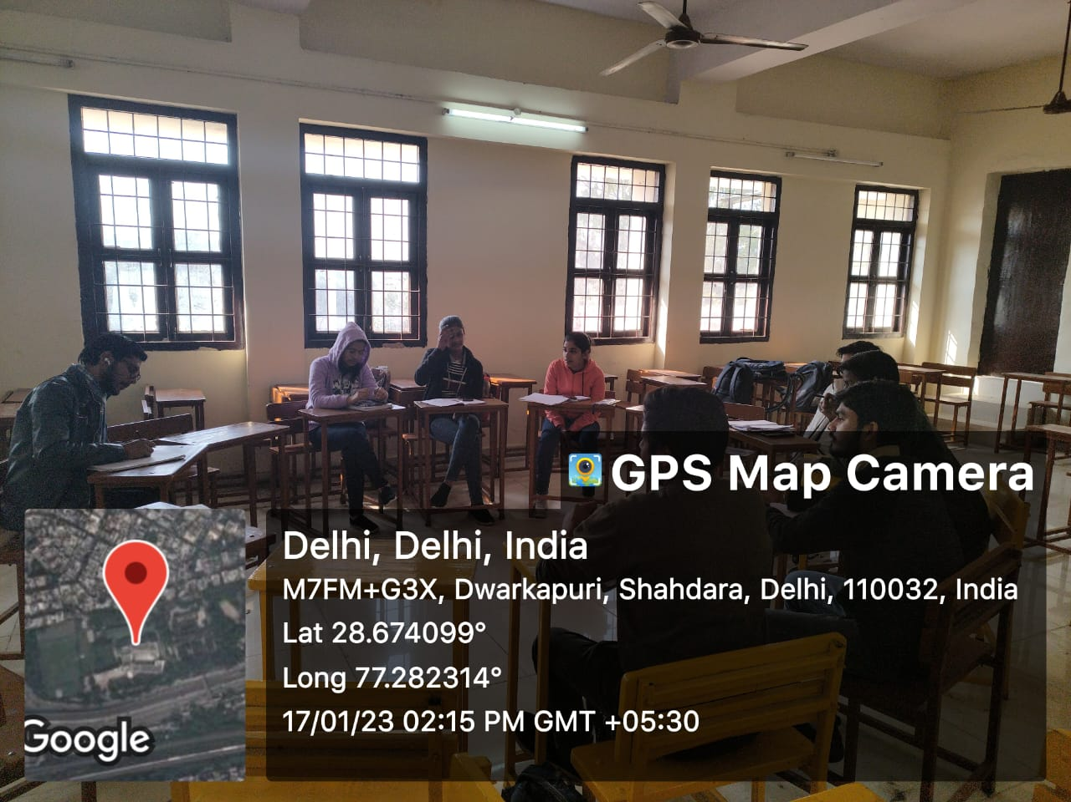
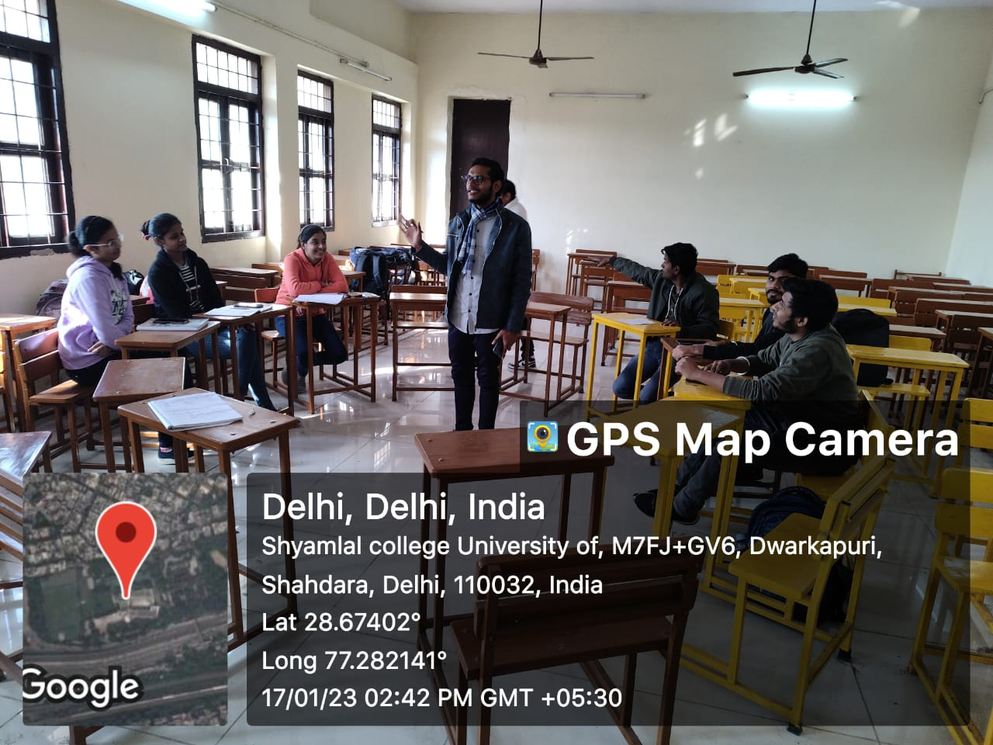
They finally drew a conclusion that ultimately balancing our views towards our culture and traditions is the need of the hour. Here’s the list of the students participated in the event.
